**ANDROID APP REVIEW SUBMISSION GUIDE LINES**

**Screenshots and Images:**

1. Take 6-8 screenshots from your app as mentioned below. (Take screenshots of all menus of sample data screen from your app)

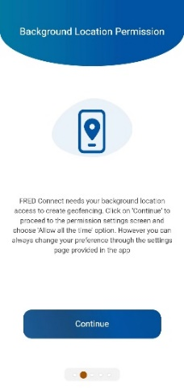 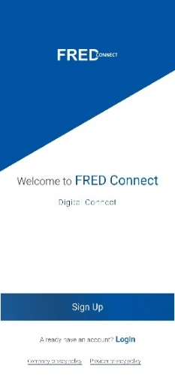 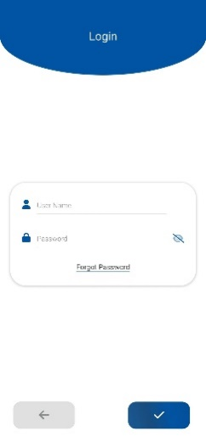 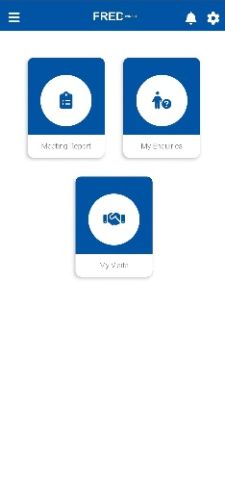

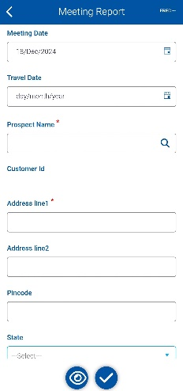 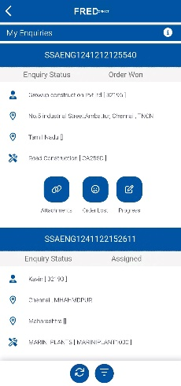

1. Crop the native and navigation bars from the screenshot. While taking screenshots make sure you have default mobile system font. Don’t use any custom fonts.

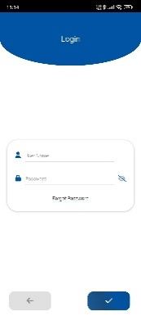 

1. **Phone screenshots**
   1. Screenshots must be PNG or JPEG, up to 8 MB each, 16:9 or 9:16 aspect ratio, with each side between 320 px and 3,840 px.
2. **7-inch tablet screenshots**

* 1. Screenshots must be PNG or JPEG, up to 8 MB each, 16:9 or 9:16 aspect ratio, with each side between 320 px and 3,840 px.

1. **10-inch tablet screenshots**
   1. Screenshots must be PNG or JPEG, up to 8 MB each, 16:9 or 9:16 aspect ratio, with each side between 1,080 px and 7,680 px.
2. **App icon**

6.1. Your app icon must be a PNG or JPEG, up to 1 MB, 512 px by 512 px.

1. **Feature graphic**
   1. Your feature graphic must be a PNG or JPEG, up to 15 MB and 1,024 px by 500 px.

**Video :**

1. You can upload a video (From strating to home page) demonstrating the app's functionality.

**NOTE** *

1. Maintain limited menus in your app in UAT.
2. Maintain the sample data for all menus in your app in UAT until it is reviewed by the Playstore team. (If your app have Time card screen, before submitting the review you can add the time card entries for next 1 week in the database).
3. Check your app Login without selecting any environment.
4. Maintain as below mentioned login credentials. Take all screenshots from your app with using this login.

USERNAME : androiduser

PASSWORD : [Androiduser@123](mailto:Androiduser@123)

**IOS APP REVIEW SUBMISSION GUIDE LINES**

**Screenshots and Images:**

1. Take 6-8 screenshots from your app as mentioned below. (Take screenshots of all menus of sample data screen from your app)

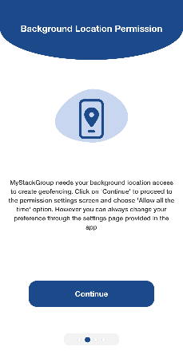 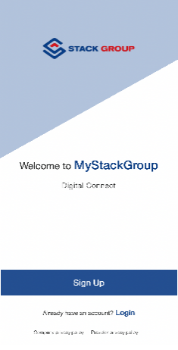 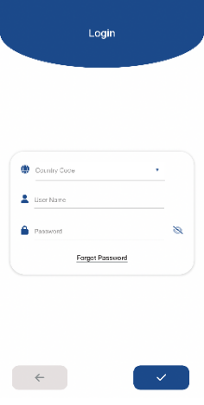 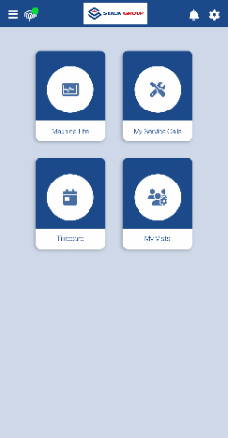

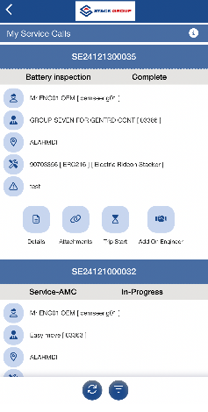 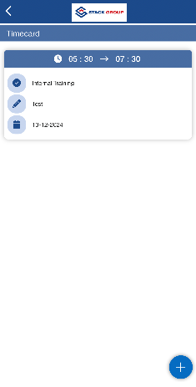

1. Remove the native and navigation bars from the screenshot. Keep your screenshots with normal fonts. Don’t use any special character and fonts.

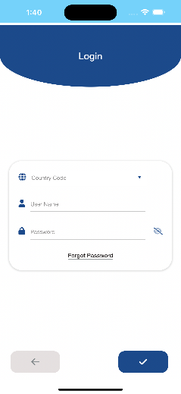

1. **Phone screenshots**
   1. iPhone 6.7" or 6.9" Displays.(1320 × 2868px, 2868 × 1320px, 1290 × 2796px or 2796 × 1290px)
2. **Ipad** 
   1. Drag up to 3 app previews and 10 screenshots here for iPad 12.9" or 13" Displays.(2064 × 2752px, 2752 × 2064px, 2048 × 2732px or 2732 × 2048px)

**NOTE** *

1. Maintain limited menus in your app in UAT.
2. Maintain the sample data for all menus in your app in UAT until it is reviewed by the Playstore team. (If your app have Time card screen, before submitting the review you can add the time card entries for next 1 week in the database).
3. Check your app Login without selecting any environment.

USERNAME : iosuser

PASSWORD : [Iosuser@123](mailto:Androiduser@123)